Lab: Advanced SQL Queries

**1 Null values**

1. Find the employees whose commission is specified (i.e. including 0.0 commissions).

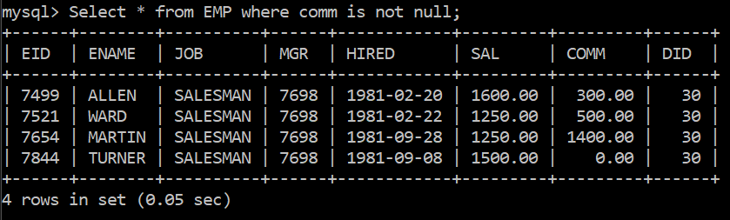

1. Find the number of employees whose commission is specified (2 methods).

First method : 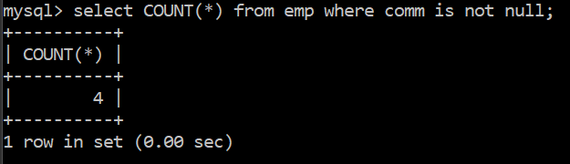

second method :

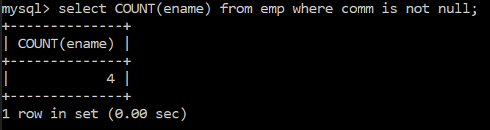

1. Find the number of employees whose commission is not specified (2 methods).

First method :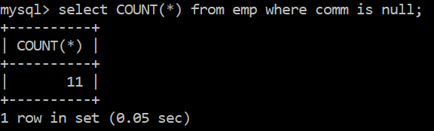

Second method :

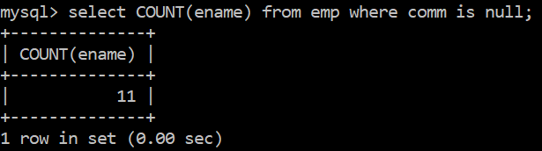

1. Find the lowest, average and highest commission over all the employees (nulls ignored).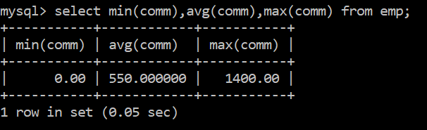
2. Find the average commission over all the employees (nulls counted as 0.0).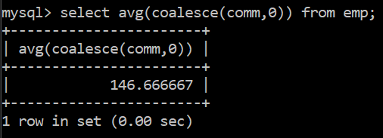
3. Find the name and commission, expressed in Euro (1 € = $ 1.2) of all the employees.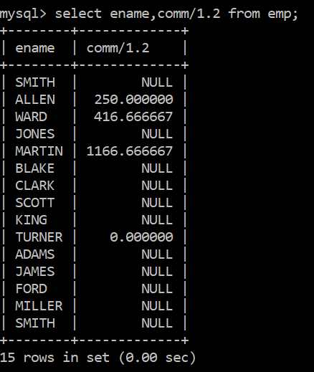
4. Find the name and total salary (including commission) of all the employees.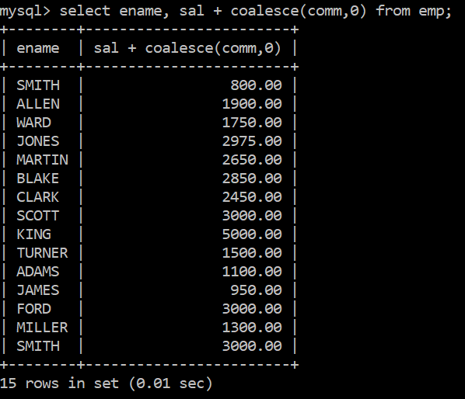
5. Find the name of the company’s top managers (i.e who don’t have a manager).
6. Find the employees whose commission is less than 25% (nulls excluded).

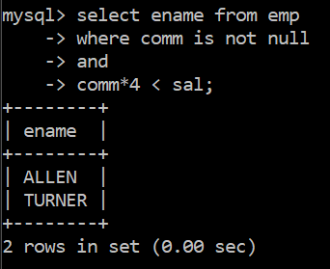

1. Find the employees whose commission is less than 25% (nulls counted as 0.0)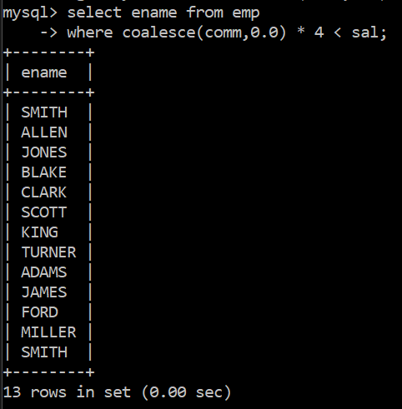

**2. SQL92 Join Queries**

1. Display (a) the product of tables EMP and DEPT, (b) the theta-join of EMP and DEPT on DID, and (c) the natural join of EMP and DEPT. Compare the schema and the population of the resulting tables.
2. select * from emp,dept;

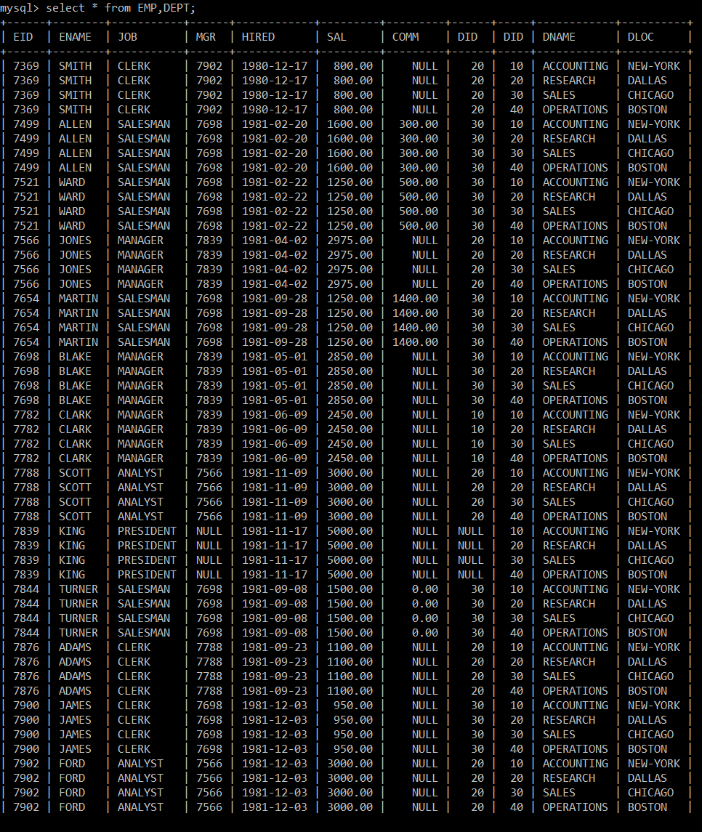



1. select * from emp INNER JOIN dept;



2. Find the name and the department of the employee who works in New-York.

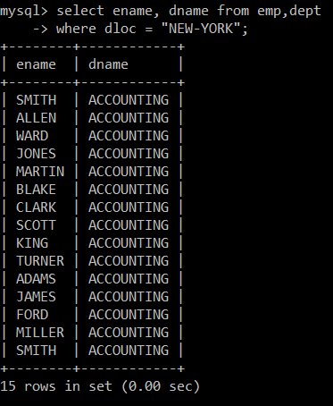

3. Find the name of the employee who did a mission in the city they work in.

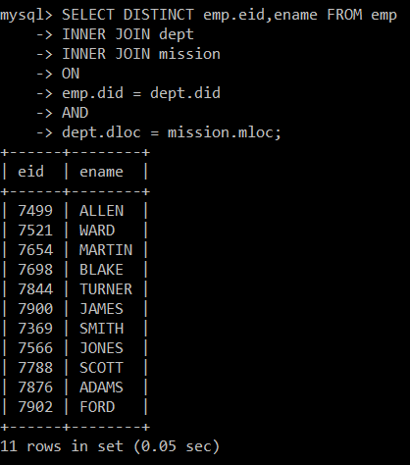

4. Find the name of the name of the employees along with the name of their manager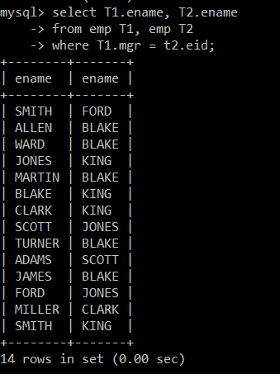

5. Find the name of the employees who have the same manager as Allen.

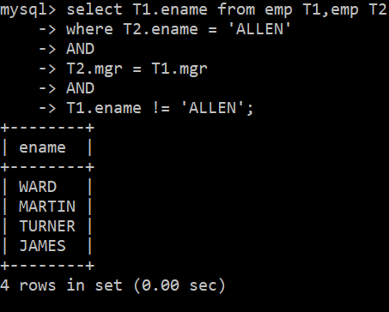

6. Find the name and hire date of the employees who were hired before their manager; also display the manager’s hire date.

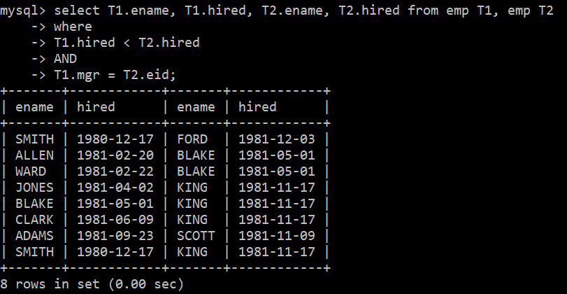

7. Find the name of the employee in the sale department who were hired the same days as an employee in the research department

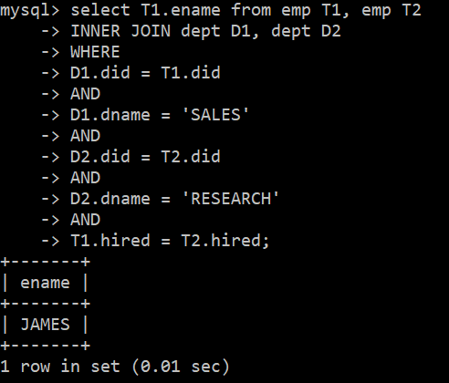

8. Find the departments that do not have any employee

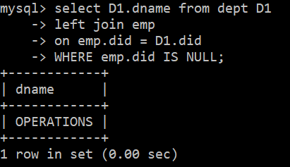

9. Find the name of the employees with the highest salary

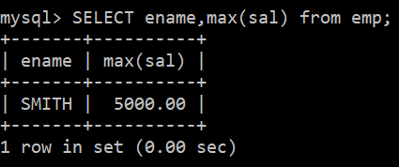

10. Find the name of the employees who were hired before all the employees of the Accounting department

**3. Subqueries**

1. Find the employees with the highest salary (2 methods).
2. 